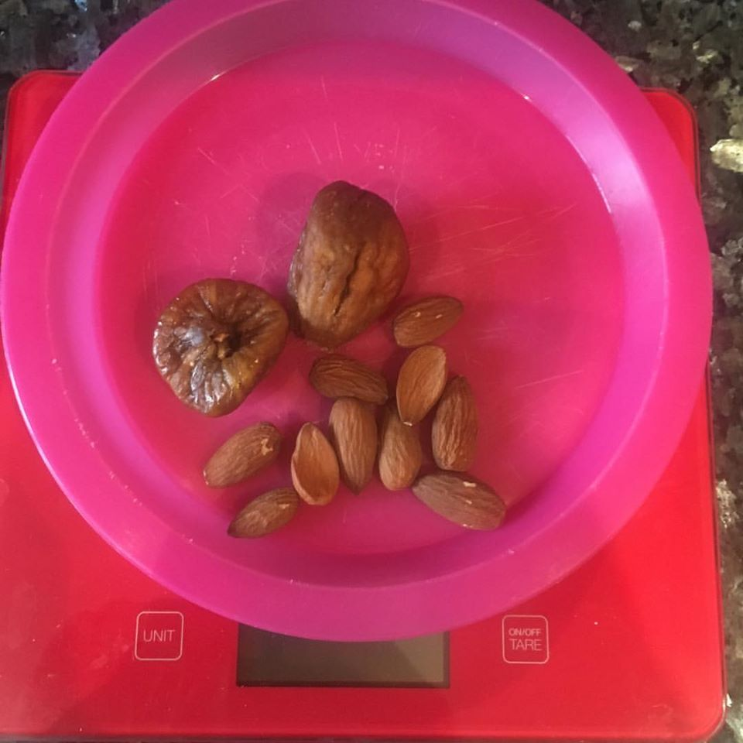

BE SNACK AWARE

BE SNACK AWARE... it's A-OK to snack BUT make sure you are aware of portion sizes and food choices. EAT FOR YOUR GOALS!

I often hear people talk about 'healthy' foods such as fruit, vegetables, nuts, seeds etc as if they are FREE calories. ***Remember all foods have calories.

If you goal is fat loss you need to remember calories IN V calories OUT... you must be in a CALORIE deficit i.e less calories IN than calories OUT.

Don’t be fooled by SMALL in quantity/volume snacks such as nuts. For example, a snack of 10 almonds and 2 dried figs although small in portion size is actually pretty high in calories... coming in at 142 calories. If you are on a low calorie intake 142 calories might be better eaten in foods that are more filling such as 2x boiled eggs (156 calories), a chicken breast to snack on (150 calories), a sugar free jelly with 1x large caramel rice cake and a protein shake (167 calories).

NOW… don’t get me wrong…Nuts are awesome and super-duper tasty, they are high in 'good' fats and a great source of protein BUT they are high in CALORIES so if you decide to snack on nuts make sure you control the portion size.

Share your low calorie snack ideas to help other FITNUTS also on a fat loss journey.

